Shopping Cart Exercise
This exercise should be discussed in the class. In this exercise you will practice how to implement a simplified shopping cart by using JavaScript. You will create a shopping cart for an online purchase order system of books. The stock information is provided by an external XML file books.xml.

You can find all the required files for this exercise on Moodle.

You can find a solution of this exercise on the course Github repository.

The outcome of this exercise should look similar to the following:
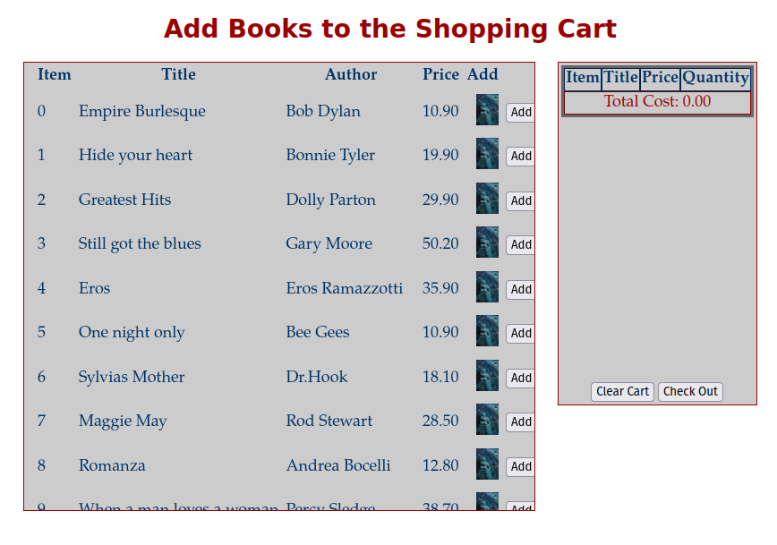

Get ready
- Create or open a website project in your preferred IDE.
- Create a new HTML file ShoppingCart.html and attach the given CSS stylesheet shopping-cart.css to the page.
- Create page elements on ShoppingCart.html by using the pre-defined styles. Here is the source code the comments explains the code:

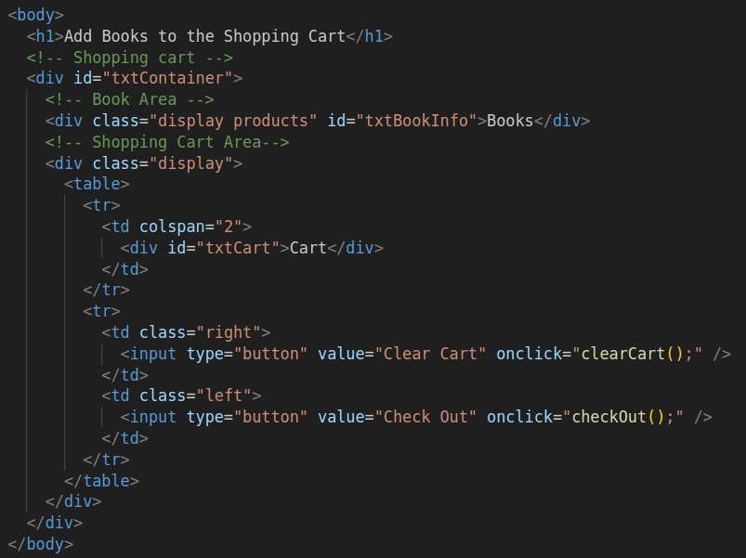
- The outcome of this part should look similar to the following:
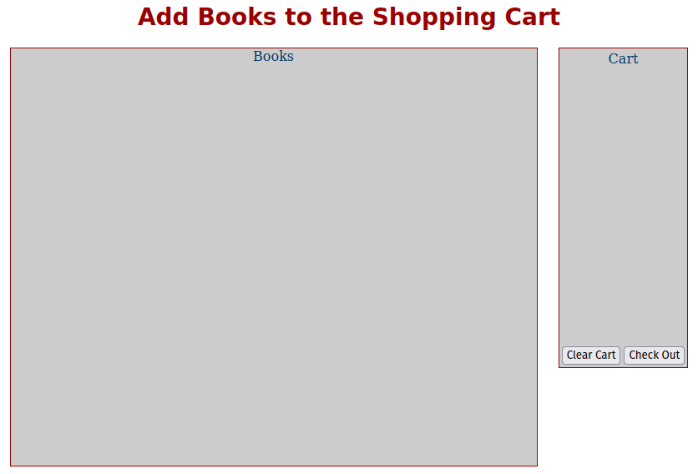
:

Load stock information from books.xml
- Create a new JavaScript file shopping-cart.js in your server folder Shopping Cart Exercise, and attach it to ShoppingCart.html.
- Inside file shopping-cart.js, define function loadXMLFile(xmlFile) which takes an XML file as a parameter and converts it into an XML Document object as the return object.
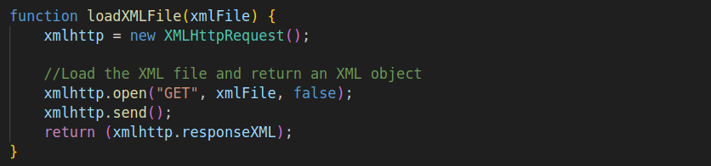
- Inside file shopping-cart.js, define two global variables to hold the shopping cart later:
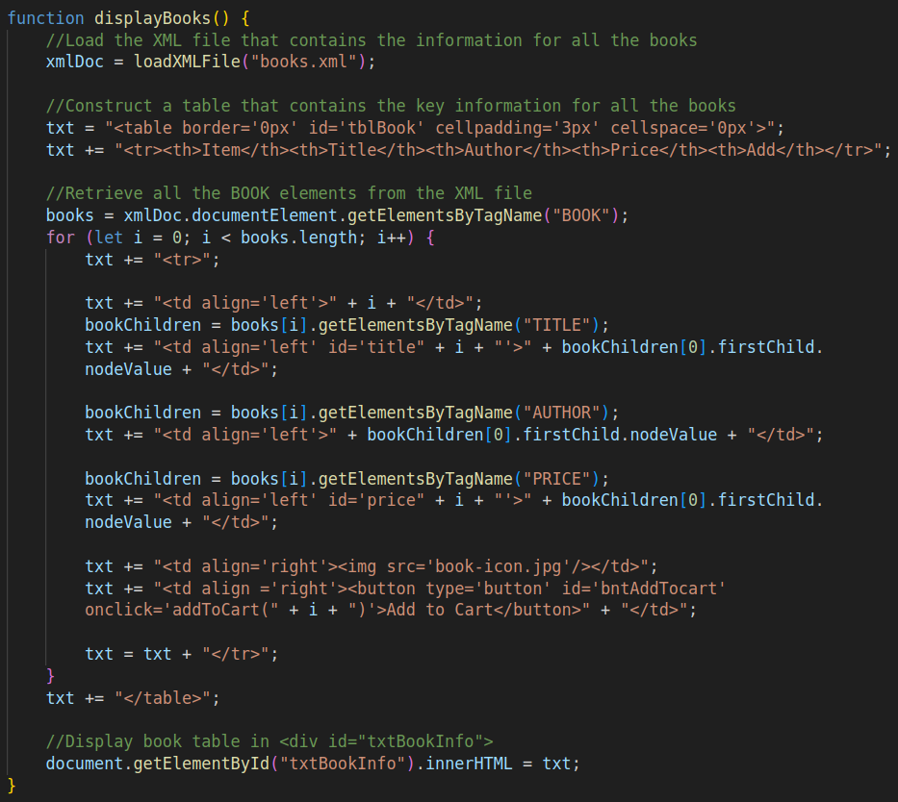
- Inside file shopping-cart.js, define function displayBooks() which loads the XML file books.xml and save the data into an XML Document object xmlDoc. It then constructs an HTML table that displays the key information for all the books within <div id="txtBookInfo">. The comments explain the code.

- Inside file shopping-cart.js, call function displayBooks() inside a window.onload event function.
- This part of the outcome should be similar to the following, when a book icon is clicked, it will call function addToCart(i) with the item number ,i.e. i, as a parameter.
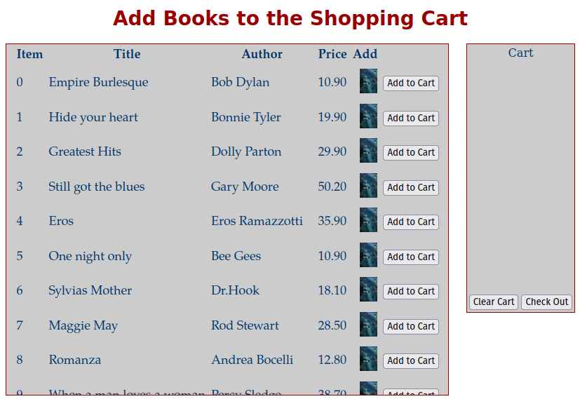

Build the shopping cart
- Inside file shopping-cart.js, define function displayCart() which constructs the shopping cart table from the global array currentCart and displays it within <div id="txtCart">. The array will hold all the selected items within the shopping cart.
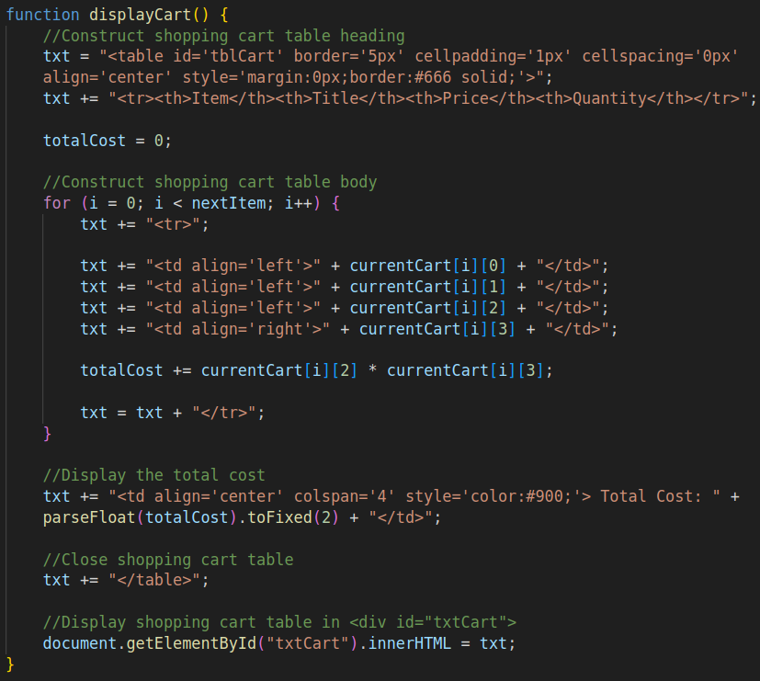
- Inside file shopping-cart.js, update the window.onload() function to also call the displayCart() function:
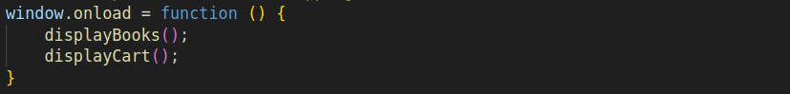
- The outcome of this part should look similar to the following:
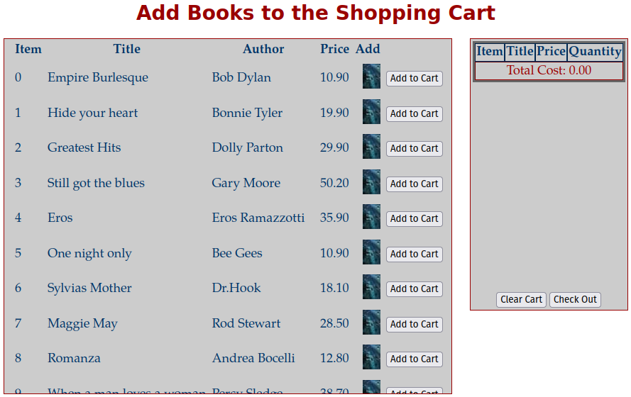
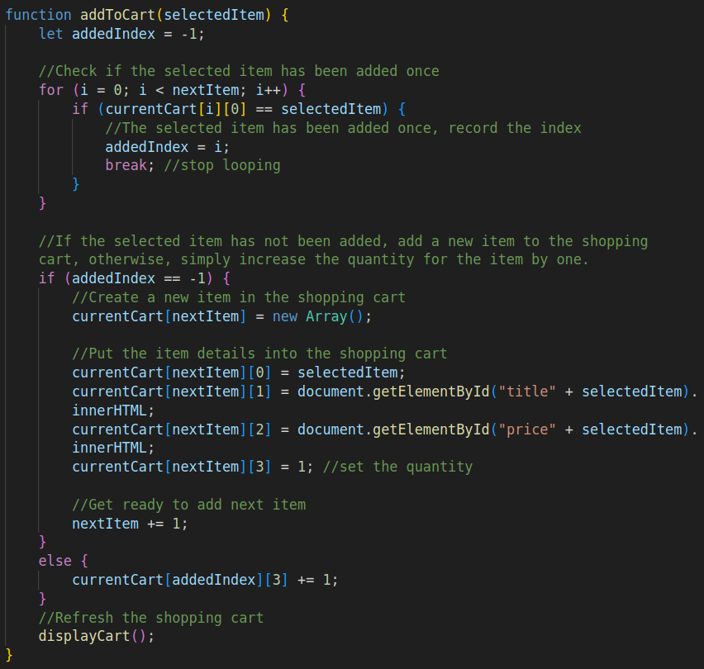
- Inside file shopping-cart.js, define function addToCart(selectedItem) which is called when a book icon is clicked. It checks if the selected item has been added once, if YES then its quantity is increased by one, otherwise, it adds a new item to the shopping cart.
- Try to click on some of the book icons, the outcome should be similar to the following:
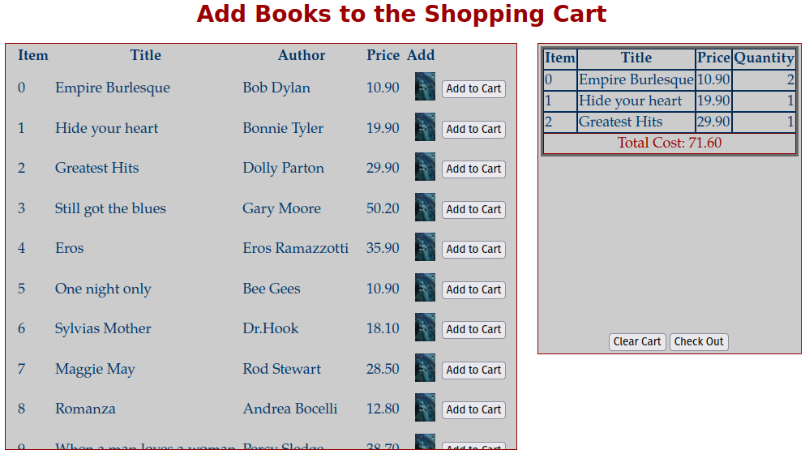

Handle the two buttons
- Inside file shopping-cart.js, define function clearCart() which is called when the Clear Cart button is clicked. It clears the current item array and refreshes the shopping cart:
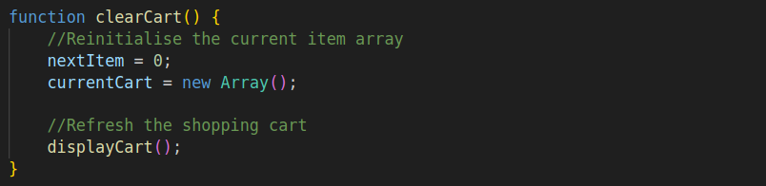
- Inside file shopping-cart.js, define function checkOut() which is called when the button Check Out is clicked. It saves the selected items in the shopping cart into an XML document object and clears the shopping cart. It also calls the given PHP file ProcessingOrder.php to save the selected items in an external XML file item.xml (when run in an environment with PHP available).
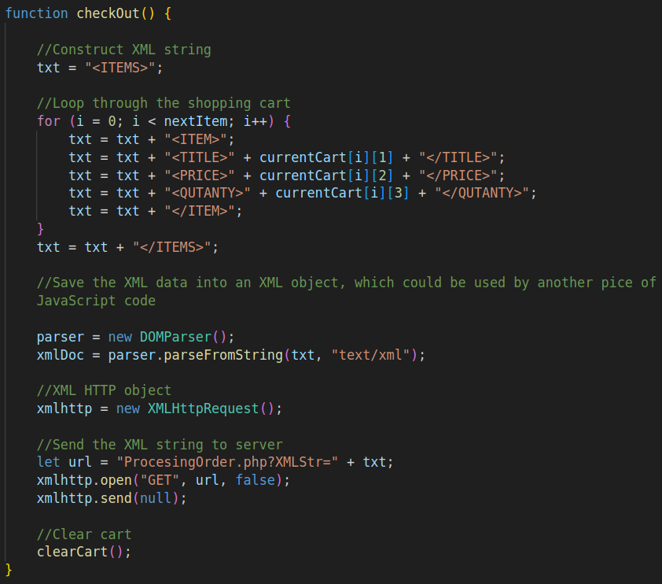

Compare your completed exercise with the solution on the course Github repository.

